Social Disability – The hidden barrier to professional growth in the disabled population

On February 12, 2009, Vice President Joe Biden announced the appointment of a Special Assistant to the President for Disability Policy. By selecting the Associate Director of White House Office of Public Engagement, Kareem Dale, to this post Obama became the first President in the US history to have a special policy advisor overseeing disability issues.

One of the key components of Obama’s policy on disability is the effort to increase access to employment for the disabled population. The White House website on Disability states:

President Obama is committed to expanding access to employment by having the federal government lead by example in hiring people with disabilities; enforcing existing laws; providing technical assistance and information on accommodations for people with disabilities; removing barriers to work; and identifying and removing barriers to employment that people with public benefits encounter

With this statement the Obama administration has identified some important employment issues associated with disability, but it seems to be focused only on bringing people with disabilities into the labor force. Once they are in, people with disabilities face a number of additional hurdles. The barriers identified by the administration fall short of addressing how to retain this population in the work force and enable a self-propelled professional growth.

What does it take to succeed in one’s career? Evidence shows that the social skills of individuals and their ability to integrate themselves into the work environment are incredibly important. Social skills - such as making friends at workplace, ability to lead a team, facilitating decision making in large teams, conveying confidence, etc. – all play a vital role in sustained professional growth. Unfortunately, people who are severely disabled, like those who are blind, often find it difficult to assimilate into the social atmosphere of their work place with the same ease of their functionally able counterpart.

“There is no professional growth without social skills”, explains Dr. Terri Hedgpeth, director of Disabilities Resource Center on Arizona State University’s campus. Hedgpeth has been blind her whole life and had to learn how to socially interact with her sighted colleagues. For instance, she learned to turn her head towards her interaction partner to mimic eye contact. She learned to hear people’s bodily movements to assess what they were communicating non-verbally.

Hedgpeth doesn’t want to be offered any social leeway because of her disability, but strongly believes in training individuals who are blind and visually impaired to learn the same social skills as their sighted peers. She laments the fact that currently there are no federal programs, either vocational or academic, that trains people who are visually impaired about important social skills in professional setting. Social training is generally reserved for children and young adults who have a severe case of tics, like body rocking or eye poking.

The social disconnect is not limited to visual impairment and blindness alone. Social implications of disabilities can be seen across the spectrum from physical disabilities like wheelchair and quadriplegia to cognitive disabilities like Autism. The disabled population faces social barriers due to their sensory, motor or cognitive dysfunction. Overcoming this social barrier cannot happen overnight through “enforcement of laws” as reported on the White House’s disability policy website. This has to happen through strong dedicated programs that study the social barrier to employment in the disabled population and offer effective solutions (social assistive aid, social education programs and co-ed of disabled and non-disabled children to encourage mutual learning of social skills, to name a few) to reduce the consequences of social disability.

The Americans with Disabilities Act was signed into law in 1990 by President George H. W. Bush and from then on, pretty much the same verbiage has followed each successive president’s agenda on disability employment. As a nation, we have been successful in moving this segment of population into the work force, but still there is a large gap in their professional success. On a wage comparison scale (data extracted from the 2008 American Community Survey questionnaires), the US visually impaired population make on an average 32% less than general population of the same age. The US physically challenged population makes 42% less. When one includes education level in these statistics, the results are even more disappointing. People with visual disability, with post graduate education, make 47% less than the average population with post graduate education and people with physical disability with post graduate degrees make 72% less than the general population with similar degrees.

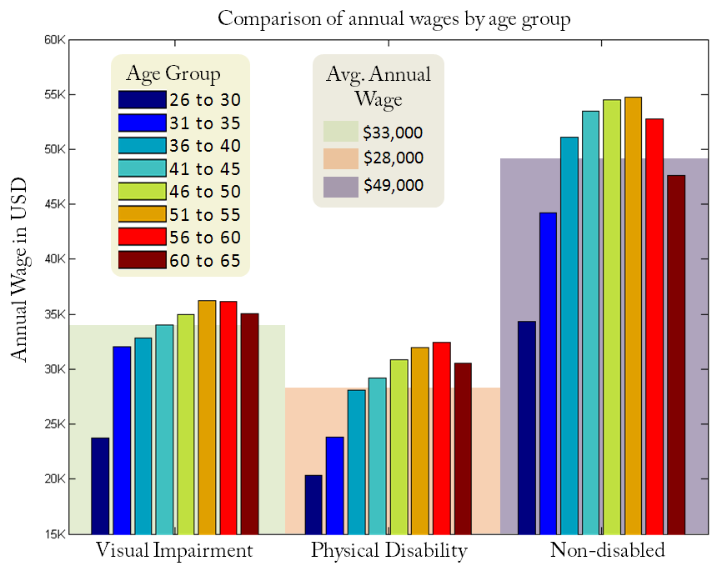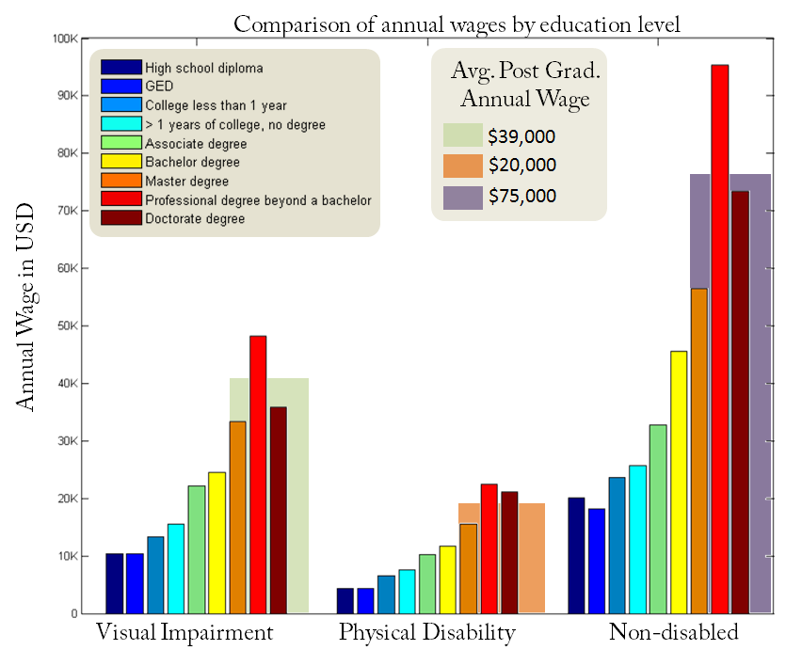

**Figure:** Comparison of annual wage of the visually impaired, physically disabled and non-disabled population. (a) Compared by age group. (b) Compared by education level.

Hedgpeth emphasizes the point that *people skills are the most important tool for professional success*. Unfortunately, social disconnect is a repercussion of disabilities. It is important to train the disabled population to circumvent their social disconnect, while we train the rest of the population to understand and acknowledge this social barrier.